STEGANOGRAPHY WITH AUDIO, VIDEO & IMAGE

SOFTWARE REQUIREMENT SPECIFICATIONS

Introduction:

Steganography with Audio, Video & Image is a console application. The purpose of this application is to provide the security for the confidential information. This application doesn’t allow the hackers to view the data, can view only Audio, Video & Image file when it is being passed over the internet. Then at the recipient side the original information i.e., plain text will be extracted from the Audio, Video & Image by performing decryption operations.

Purpose of SRS:

The purpose of this Software Requirement Specification (SRS) is to help the project. It is provided with some requirements which are used in Steganography with Audio, Video & Image. All parts; design, coding and testing will be prepared with helping of SRS. The purpose of this document is to detail the requirements placed on the Java Explorer. System and serves as a contract between the customer and the developers as to what is to be expected of the Java Explorer, and how the components of the system are to work with each other with external systems.

This document will be checked by group member’s supervisor and it will corrected by members if supervisor orders.

Scope:
Animations can not be send via this application. Only .wmp video files can only encrypted . text files can not be used in this application as Source file.

Users:
- User

Definitions, Acronyms and Abbreviations:
SLA: Service Level Agreement or SLA is a formal written agreement made between two parties, the service provider & the service recipient. It defines the term of engagement - the fundamental rules that will govern the relationship.
- JAVA: Java is internet software which is used to develop distributed /web applications and it’s also integral to the intranet applications and other e-business solutions that are the foundation of corporate computing.

- SRS: Software Requirement Specification.

- Awt: Abstract window tool kit is mainly used to develop GUI based applications

- Swings: Swings are advanced technology of applets which is derived from AWT

- Action Event: Action Event is one of the sub package in event package.

- Event Handling: Event Handling is one of mechanism to handle the various events performed by different components.

- ActionListener: ActionListener is one of predefined interface found in java.awt.event.

Reference:
- IEEE Standard Format for SRS.
- http://www.sun.com
- http://www.oracle.com/technetwork/java/index.html
- http://www.java2s.com
- http://koderguru.com

Technologies to be used:

Programming languages:

JAVA: java technology is a high-level programming and a platform independent language. Java is designed to work in the distributed environment on the Internet.

Tools & Development Environment:

- Operating System : Microsoft Windows XP/2000 or Higher
- Clients: CONSOLE
- Development Tools: Net beans 6.8
- Documentation Tools: MS Office 2003/2007
- Drawing Tools: IBM Rational Rose Enterprise, MS Office Visio 2007
- User Interface: AWT & SWINGS
- Code Behind: AWT AND SWINGS

Software Interface:
- Client: CONSOLE.
- Development End: NetBeans6.8

Hardware Requirements:
Client Side
 | Processor | RAM | Disk Space
Console | Computer with a 2.6GHz processor or higher (Pentium processor recommended) | 512MB Minimum | Minimum 20 GB
Server Side
Net Beans 6.8 | Intel Pentium Processor at 2.6GHz or faster | Minimum 512 MB Physical Memory; (1 GB Recommended) | Minimum 20 GB

Communication Interface:
- Access of the CMS within Local Network will be using TCP/IP Protocol.

Existing System:

The existing system is manual and the manual system works in the following way:

Disadvantages:
- If a person sends sensitive information over the insecure channels then there may be a chance of hacking it.
- They can alter the information and resends it over the network.
- We cannot embed the data in to image therefore it is not secure.
- If a person sends sensitive information over the insecure channels then there may be a chance of hacking it.
- They can alter the information and resends it over the net.
- We cannot embed the data in to image therefore it is not secure.

Proposed Systems:

To overcome all the difficulties of the existing system the management has proposed automated the whole system and the development of the new automated system contains the following activities.

Advantages:
- In the proposed system the problem has been solved by embedding the data into the Audio, Video & Image file.
- Before embedding it into the file, encryption operation will be performed by using the encryption key which is provided by the source.
- Then this Audio, Video & Image file will be passed over the network, even if hacker hacks it, he can be able to see only an Audio, Video & Image file.
- At the destination side this data will be encrypted from Audio, Video & Image file and performs decryption to get original message.
- It provides more security.

Functional Requirements:

Following is a list of functionalities of the system
Functional requirement means interface between user and the hardware.
In this project, we discuss the functionalities of the each module. The functional requirements are:

- In the Encryption process each LSB (Least Significant Byte) will be replaced by the encrypted data.
- Embedding it into the file, encryption operation will be performed by using the encryption key which is provided by the source.
- During Decryption process each data will be extracted from each LSB and then performs decryption operation which results into a plain text which was sent by the source side.
- At the Destination side, this data will be encrypted from Audio, Video & Image file and performs decryption to get original message.

Non-Functional Requirements:

The system should be Stand Alone Application. The system should have Role based System functions access. Approval Process has to be defined.

- 24 X 7 availability
- Better component design to get better performance at peak time
- Flexible service based architecture will be highly desirable for future extension

Study of the System:

To provide flexibility to the users, the interfaces have been developed that are accessible through a console. The GUI’S at the top level have been categorized as
The operational or generic user interface

The ‘operational or generic user interface’ helps the end users of the system in transactions through the existing data and required services. The operational user interface also helps the ordinary users in managing their own information in a customized manner as per the included flexibilities.

Users of the System:

This system should be designed to support the following users:
- User

Modules:

After looking at the functional requirements it is identified that we can divide the system into mainly following modules:

GUI Module:

This module generates the user interface through which a user browses the Audio, Video & Image file and can play and stop the Audio, Video & Image file. This GUI contains different fields such as text area for entering message and buttons for encryption and decryption.

Encryption and Decryption Module:

In this module, , LSB of the each byte of Audio, Video & Image file will be replaced by the encrypted data which is generated by the combination of the encryption key and the plain text i.e., the original message. Then this Audio, Video & Image file will be sent to the recipient. At recipient side this encrypted data will be extracted from each LSB and performs decryption operation on it and gives original information.

SDLC METHODOLOGIES:

This document play a vital role in the development of life cycle (SDLC) as it describes the complete requirement of the system. It means for use by developers and will be the basic during testing phase. Any changes made to the requirements in the future will have to go through formal change approval process.

SPIRAL MODEL was defined by Barry Boehm in his 1988 article, “A spiral Model of Software Development and Enhancement. This model was not the first model to discuss iterative development, but it was the first model to explain why the iteration models.

As originally envisioned, the iterations were typically 6 months to 2 years long. Each phase starts with a design goal and ends with a client reviewing the progress thus far. Analysis and engineering efforts are applied at each phase of the project, with an eye toward the end goal of the project.

The steps for Spiral Model can be generalized as follows:

- The new system requirements are defined in as much details as possible. This usually involves interviewing a number of users representing all the external or internal users and other aspects of the existing system.
- A preliminary design is created for the new system.
- A first prototype of the new system is constructed from the preliminary design. This is usually a scaled-down system, and represents an approximation of the characteristics of the final product.

A second prototype is evolved by a fourfold procedure:

- Evaluating the first prototype in terms of its strengths, weakness, and risks.
- Defining the requirements of the second prototype.
- Planning a designing the second prototype.
- Constructing and testing the second prototype.

At the customer option, the entire project can be aborted if the risk is deemed too great. Risk factors might involve development cost overruns, operating-cost miscalculation, or any other factor that could, in the customer’s judgment, result in a less-than-satisfactory final product.

- The existing prototype is evaluated in the same manner as was the previous prototype, and if necessary, another prototype is developed from it according to the fourfold procedure outlined above.
- The preceding steps are iterated until the customer is satisfied that the refined prototype represents the final product desired.
- The final system is constructed, based on the refined prototype.
- The final system is thoroughly evaluated and tested. Routine maintenance is carried on a continuing basis to prevent large scale failures and to minimize down time.

The following diagram shows how a spiral model acts like:

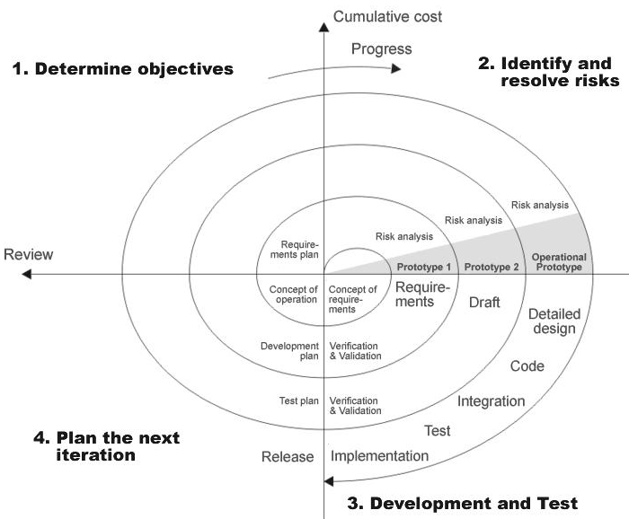

Fig 1.0: Spiral Model

The developer is responsible for:

- Developing the system, this meets the SRS and solving all the requirements of the system.
- Demonstrating the system and installing the system at client's location after the acceptance testing is successful.
- Submitting the required user manual describing the system interfaces to work on it and also the documents of the system.
- Conducting any user training that might be needed for using the system.
- Maintaining the system for a period of one year after installation.

CONTEXT DIAGRAM: (0 Levels DFD)
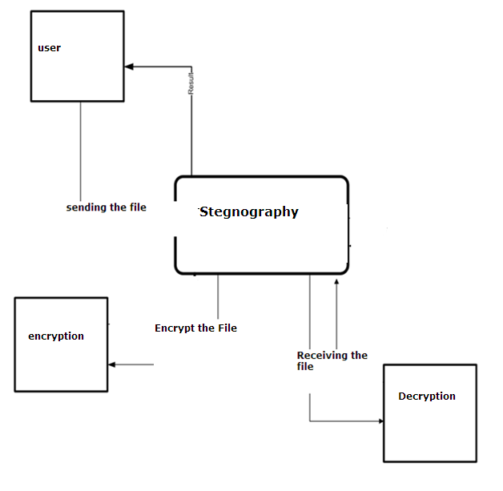

PERFORMANCE REQUIREMENTS:

Performance is measured in terms of the output provided by the application. Requirement specification plays an important part in the analysis of a system. Only when the requirement specifications are properly given, it is possible to design a system, which will fit into required environment. It rests largely in the part of the users of the existing system to give the requirement specifications because they are the people who finally use the system. This is because the requirements have to be known during the initial stages so that the system can be designed according to those requirements. It is very difficult to change the system once it has been designed and on the other hand designing a system, which does not cater to the requirements of the user, is of no use.

The requirement specification for any system can be broadly stated as given below:

- The system should be able to interface with the existing system
- The system should be accurate
- The system should be better than the existing system

The existing system is completely dependent on the user to perform all the duties.

FEASIBILITY REPORT:
Preliminary investigation examine project feasibility, the likelihood the system will be useful to the organization. The main objective of the feasibility study is to test the Technical, Operational and Economical feasibility for adding new modules and debugging old running system. All system is feasible if they are unlimited resources and infinite time. There are aspects in the feasibility study portion of the preliminary investigation:

- Technical Feasibility
- Operation Feasibility
- Economical Feasibility

Technical Feasibility

The technical issue usually raised during the feasibility stage of the investigation includes the following:

- Does the necessary technology exist to do what is suggested?
- Do the proposed equipments have the technical capacity to hold the data required to use the new system?
- Will the proposed system provide adequate response to inquiries, regardless of the number or location of users?
- Can the system be upgraded if developed?
- Are there technical guarantees of accuracy, reliability, ease of access and data security?

Earlier no system existed to cater to the needs of ‘Secure Infrastructure Implementation System’. The current system developed is technically feasible. It is a web based user interface for Online Project Management. Thus it provides an easy access to the users. The database’s purpose is to create, establish and maintain a workflow among various entities in order to facilitate all concerned users in their various capacities or roles. Permission to the users would be granted based on the roles specified. Therefore, it provides the technical guarantee of accuracy, reliability and security. The software and hard requirements for the development of this project are not many and are already available in-house or are available as free as open source. The work for the project is done with the current equipment and existing software technology. Necessary bandwidth exists for providing a fast feedback to the users irrespective of the number of users using the system.

Operational Feasibility

Proposed projects are beneficial only if they can be turned out into information system. That will meet the organization’s operating requirements. Operational feasibility aspects of the project are to be taken as an important part of the project implementation. Some of the important issues raised are to test the operational feasibility of a project includes the following: -

- Is there sufficient support for the management from the users?
- Will the system be used and work properly if it is being developed and implemented?
- Will there be any resistance from the user that will undermine the possible application benefits?

This system is targeted to be in accordance with the above-mentioned issues. Beforehand, the management issues and user requirements have been taken into consideration. So there is no question of resistance from the users that can undermine the possible application benefits.
The well-planned design would ensure the optimal utilization of the computer resources and would help in the improvement of performance status.

Economic Feasibility

A system can be developed technically and that will be used if installed must still be a good investment for the organization. In the economical feasibility, the development cost in creating the system is evaluated against the ultimate benefit derived from the new systems. Financial benefits must equal or exceed the costs. The system is economically feasible. It does not require any addition hardware or software. Since the interface for this system is developed using the existing resources and technologies available at NIC, There is nominal expenditure and economical feasibility for certain.

